HILL LANE SURGERY Newsletter
January 2022
Firstly, all at Hill Lane Surgery would like to wish you a very Happy New Year.  Unfortunately, Covid-19 is still very much alive and kicking and we would encourage you to get your boosters if you haven’t already. Either call 119 or visit the NHS website. |  | Don’t forget we are always here to help, and we are still offering ‘face to face’ appointments as well as telephone consultations, just let us know which you would prefer when booking with our reception team. Here’s to a better 2022. Kind regards Laura Practice Administrator | COVID-19 Boosters  Walk in clinics are still available for a Covid booster. Visit the NHS website for more information.  With the NHS App you can book and cancel appointments, order prescriptions, and view your medical history and immunisations.  You can also get access to your Covid-19 pass.
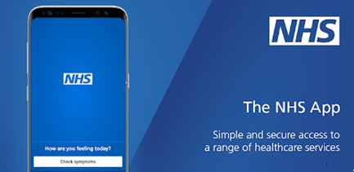

Steps 2 wellbeing
Do you suffer from any of the following?
Anxiety
Depression
Stress
Social anxiety
Specific phobias
Panic
Post-Traumatic Stress Disorder (PTSD)
Obsessive Compulsive Disorder
Is life sometime difficult because of how you feel? Are you or someone you care about feeling scared, anxious, low, or stressed? Come and have a chat with your GP OR you can even self-refer! Why not go to their website and find out how? www.steps 2wellbeing.co.uk
 |  | 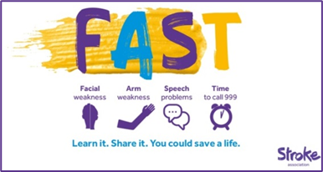
https://www.jostrust.org.uk/about-us?gclid=CjwKCAiAhfzSBRBTEiwAN-ysWIVlPzyexe1oe2o5AZ3ZG0S500W5xKV9ymS5hBKyq90IyKuUZhqHARoCWPkQAvD_BwE  Please call the surgery to book an appointment if your smear is due. Please click on the link above for more information, and answers to lots of questions about cervical screening.  "A smear test lasts 5 minutes. The Impact of cervical cancer lasts a lifetime"  Attend your smear test. |  | The Stroke Association are the UK’s leading charity dedicated to conquering strokes. For more information visit: www.stroke.org.uk

